**ASSIGNMENT 12.1**

**Importing acadgild_spark vm using Oracle vm**

**Install oracle virtual box**

**Steps to import acadgild vm:**

1.Open the virtual box and then follow the below steps:

Click on File --→ Import Appliance.

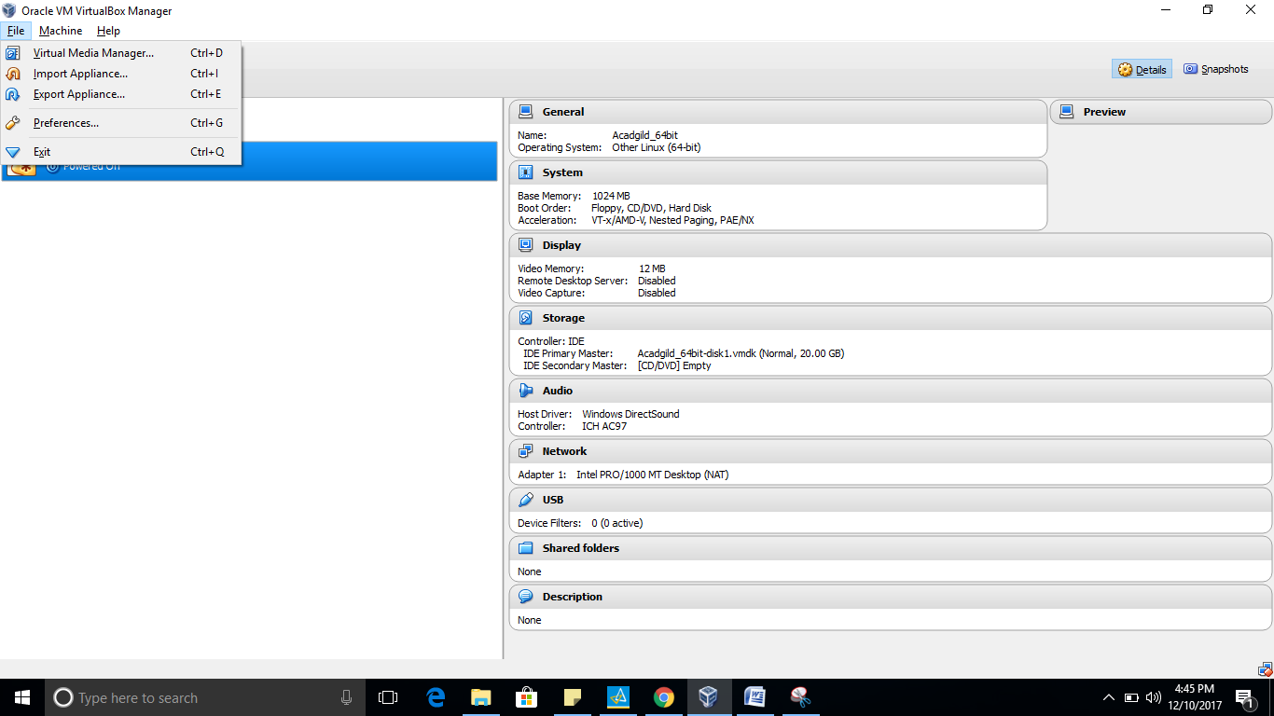

2. Click on the Folder option as shown in the below screenshot

to browse to the location where hadoop vm is present.

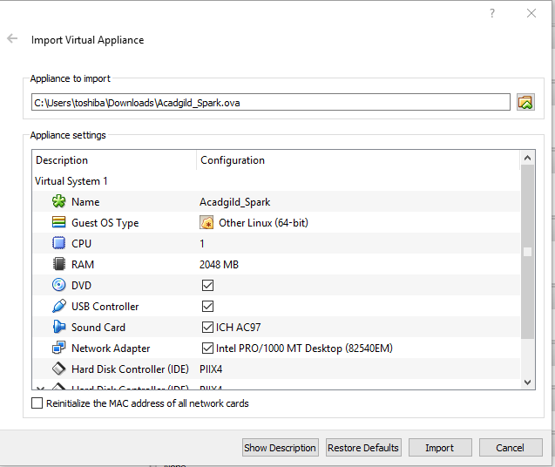

Step3-Click on import button to start importing the acadgild

VM. Once the vm starts getting imported it gives a prompt and Once the importing gets finished, we need to click on the start button.

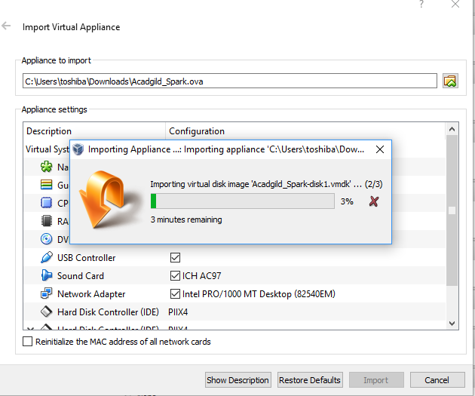

Step4-We need to give the password as acadgild.

Password: acadgild

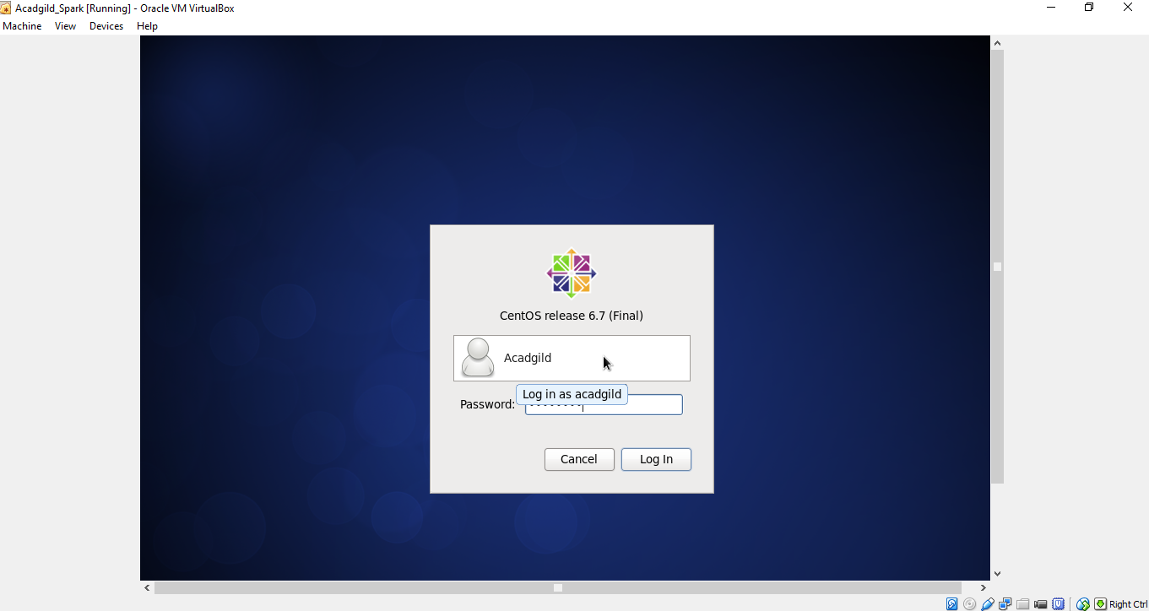

Step5-Open the terminal and type the command jps to

check the list of daemons, we need to start all the

daemons for the first time.

Starting NameNode, DataNode, ResourceManager, NodeManager and

Jobhistoryserver

NOTE: Change the directory to sbin of hadoop before starting the daemon.

In the VM hadoop-2.6.0 is present in /user/local directory

Command: $ cd hadoop-2.6.0

$ cd sbin

Starting namenode:

Command: ./hadoop-daemon.sh start namenode

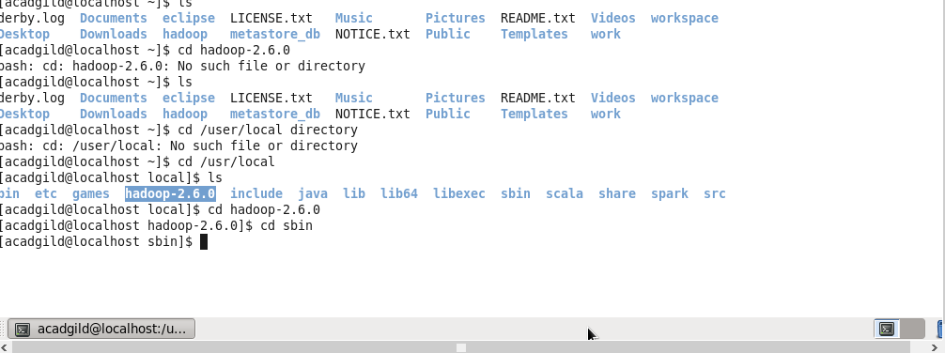

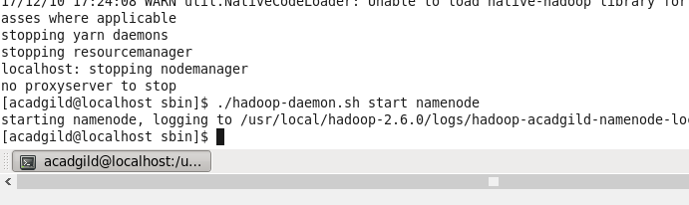

Starting datanode:

Command: ./hadoop-daemon.sh start datanode



Starting resourcemanager:

Command: ./yarn-daemon.sh start resourcemanager



Starting nodemanager:



Type the command jps to check the health of the

daemons, if all the daemons will be running then cluster

is ready.

